Electrical and Computer Engineering Department

EEL 6836 – Computer Visualization of Brain Electrical Activity

Professor: Mercedes Cabrerizo

Student: Jose David Cedeno

Panther ID: 5846915



Interictal Spikes Detection

Implementing Neural Networks

1. ABSTRACT

Epilepsy is an illness that affects a sizeable percentage of the people worldwide, being one of the most common neurological diseases globally. The brain’s electrical activity can be measured using Electroencephalogram (EEG) data, which neurologists can study in order to find the source of epileptic seizures in the human brain. This process can consume a lot of a neurologist’s valuable time, since they have to manually analyze hours of EEG data. The purpose of this project is to find an automated method to detect interictal spikes in EEG data, in order to simplify the neurologist’s job by saving time, which will in consequence reduce costs associated to EEG testing.

2. INTRODUCTION

Epilepsy is an illness of the human brain in which the patient suffers “recurrent, unprovoked seizures”[1], and although this disorder is not lethal or contagious, it can be dangerous to the individual because of its unpredictable nature, since seizures can happen at any moment without warning, and could put the patient’s and other people’s lives at risk. The study of this illness is important because it “affects approximately 50 million people worldwide”[2], and there is a need to improve the processes involved in the detection of the area of the brain that is responsible for the seizures. To achieve this, several examinations are performed, some of which are the Electroencephalogram (EEG), Magnetic Resonance Imaging (MRI), Functional Magnetic Resonance Imaging (FMRI), and Positron Emission Tomography (PET). The EEG is preferred due to its lower cost and higher time resolution to detect events happening in the brain.

The analysis of EEG data is done manually by neurologists, who perform a visual examination of the data and decide where and when Interictal spikes occur relying only on their expertise. This process can take up a lot of a neurologist’s valuable time, and so, an important advancement would be the implementation of an automated method to detect interictal spikes, alleviating some of the neurologist’s work.

3. METHODS

3.1 Raw Data and Signal Processing

The patient had five different seizures which were recorded in five different files called sz1_cleaned (5minB 2minA), up to sz5_cleaned (5minB 2minA). These files were filtered using the open source MatLab toolbox EEGLAB, which applies a band-pass filter to the data. The lower edge of the band-pass filter was selected to 1 Hz in order to filter out the continuous EEG data, which is recommended by the EEGLAB tutorial webpage[3]. The filtered data was saved into the MatLab workspace.

3.2 Interictal Spike Morphological Features

The morphological features of a spike are defined by Adjouadi ET. Al. in their publication “Detection of Interictal Spikes and artifactual Data through Orthogonal Transformations”; the ones considered by this project are cited here:

“a. A spike is estimated to have a total duration of 20 to 70 milliseconds. This is, at a sampling rate of 500 Hz, between 10 and 35 samples.

b. The maximum amplitude of a spike is at least 1.5 times larger than that of the background signal, where the background signal may be defined as the EEG activity lasting twice the duration of the spike at either side of a potential spike.

c. Multi-channel activity may be reported, where one spike observed in a given channel may also be observed in another neighboring channel. In other words, spikes do not occur in isolation.

d. A slow wave may follow a spike. This characteristic, not always present, may be used only to augment the certainty in identifying a spike, but not to undermine it.”[4]

3.3 Interictal Spikes Training Data and Target Data

The raw EEG data from sz1 (‘sz1_cleaned (5minB 2minA)’) was accompanied by a word file with the time locations of interictal spikes that occurred in this specific seizure EEG data file. The neural network requires training data to be pre-classified, in other words, it needs to know which samples belong to the ‘interictal spike’ (positive) class, and which samples belong to the ‘non-interictal spike’ (negative) class, which is why the sz1 data is used to train the neural network.

A problem with this data is that the proportion of the data belonging to the positive class to the data belonging to the negative class was very low, so an up-sampling of the positive class data was performed to the training data, in order to increase the number of positive samples and increase the accuracy of the neural network.

The first step in this process was to separate the interictal spikes (positive class) from the non-interictal spikes (negative class) and save them in different variables. The second step was concatenating the positive class samples after intervals of ten percent of negative class data, ensuring that every ten percent of training data will contain the positive class data. The third step was defining the target data, which was defined as a single-vector data with length equal to the number of samples in the training data. The target data is zero (0) for samples that belong to the negative class, and one (1) for the samples that belong to the positive class.

3.4 Neural Network Training

The neural network was trained with the MatLab neural network toolbox, using the training data obtained with the process mentioned previously which ensures it to have positive class data in each ten percent cluster of data.

3.5 Neural Network Testing

The sz2 (‘sz2_cleaned (5minB 2minA)’) up to sz5 (‘sz5_cleaned (5minB 2minA)’) data were used as input data to the neural network obtained with the training data from the sz1 (‘sz1_cleaned (5minB 2minA)’) data. A visual inspection of the positive classes was made in order to determine the success rate of the neural network.

4. RESULTS

The neural network was designed to have 20 neurons in its input layer which are the 20 electrodes relevant to the analysis of the seizure data as defined in the information file attached to the raw data, 20 neurons in its hidden layer, and 1 neuron in its output layer which will be closer to 0 if the sample belongs to a negative class, and 1 if it belongs to a positive class. Figure 1 shows the neural network diagram selected for this project.

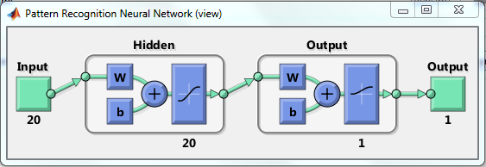

Figure 1 Neural Network Diagram

The number of neurons in the hidden layer is decided arbitrarily, and should be modified depending on the results obtained after testing.

Figure 2 shows the ROC curve of the neural network, it can be observed that the neural network’s performance is above the chance performance, although, a better performance is desired.

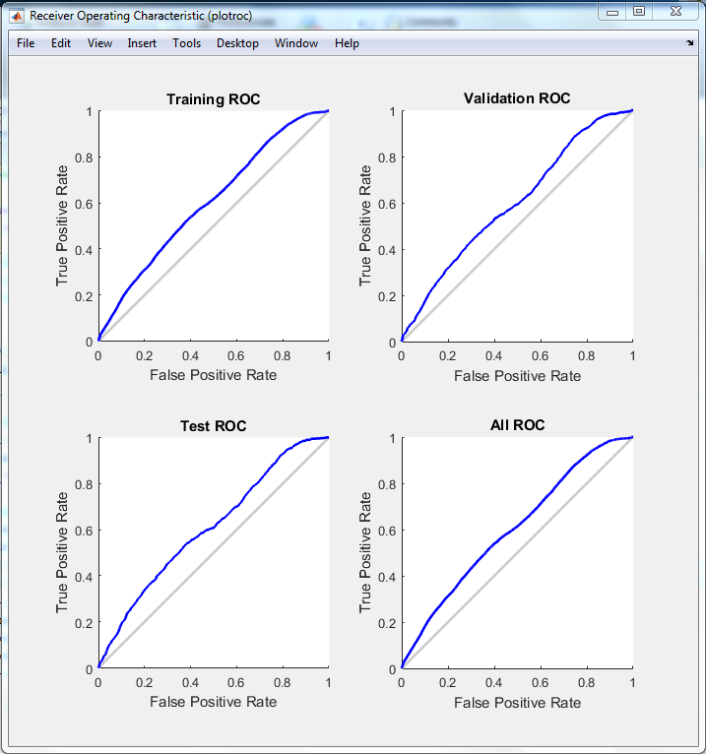

Figure 2 ROC curve

Figures 3 shows the filtered EEG data of sz2 for a thirty-five-second window (from 80 to 115 seconds), and figure 4 shows the samples classified as positive class (spikes) by the neural network for this same data window.

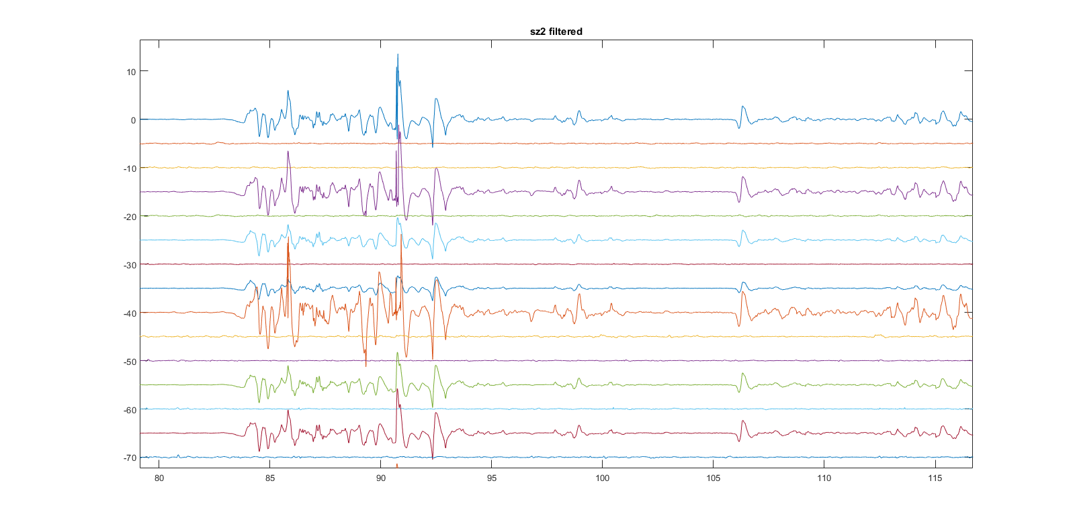

Figure 3 Seizure 2 filtered data

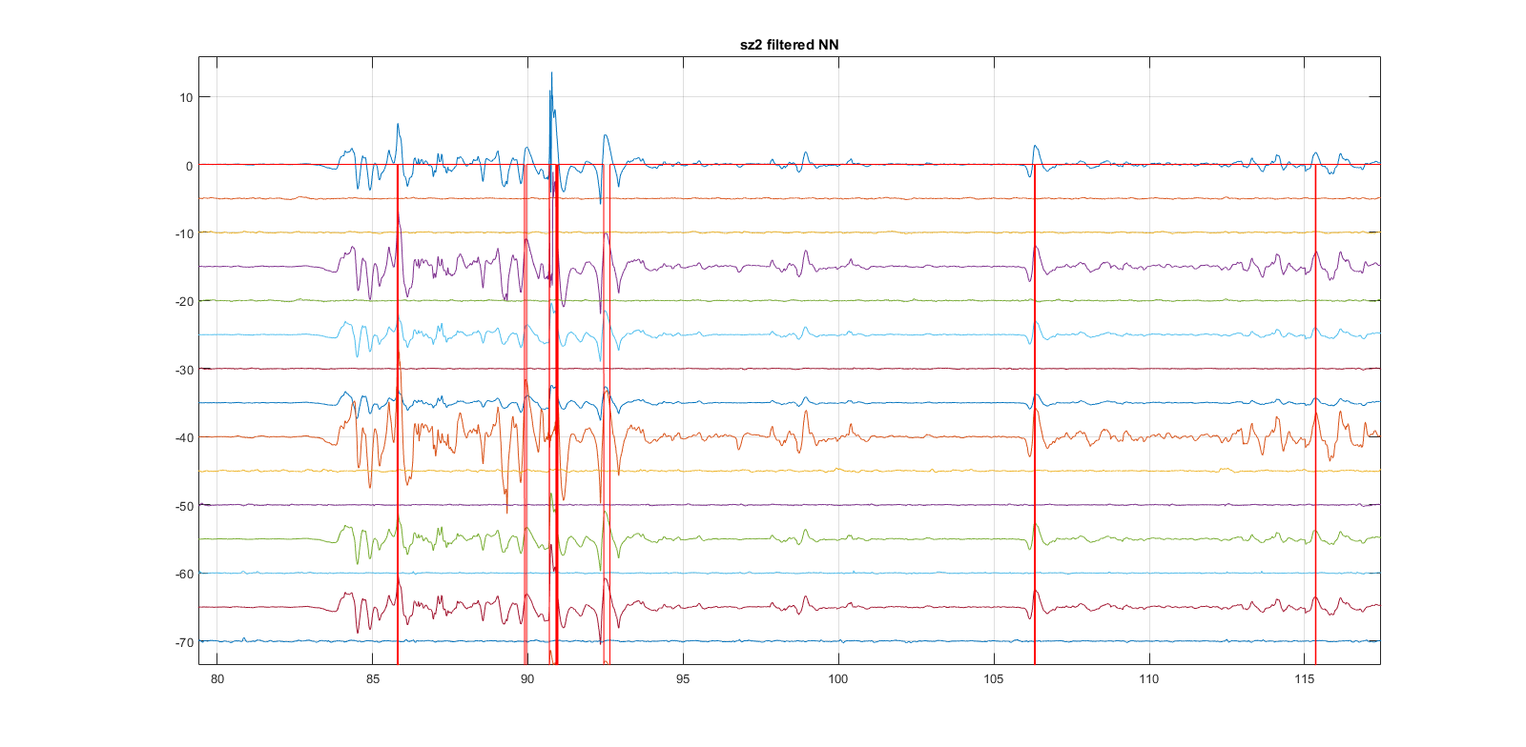

Figure 4 Seizure 2 filtered data: Classification Results

A visual inspection of these figures tells us that the network is classifying the desired data as positive, e.g. data that has the morphological shape of an interictal spike, and is present in different channels which are physically close to each other, as previously defined in 3.2.

It can also be observed that there are some samples classified as positive that do not show the characteristics of an interictal spike.

5. CONCLUSION

The neural network trained using the sz1 data has acceptable results for classifying spikes of a single patient, however, the next step is to generalize the results for data recorded from different epileptic patients. Each electrode’s recorded data was selected as the neural network’s features, a possible improvement is to add features like each electrode’s mean, standard deviation, and slope, as features to the input data. This way, the neural network will have more information to decide at the moment of sample classification. The slope defines the speed at which the amplitude changes, the standard deviation will give a relative minimum amplitude for classification of interictal spikes, which will depend on each patient, and the mean will give a reference value for each electrode’s samples, complementing the standard deviation’s information.

Another recommendation is the implementation of deep learning networks and convolutional neural networks. With deep learning, we train the original neural network with the data it receives for classification, in other words, the network is learning from the new data it receives, always improving its performance. With convolutional neural networks, we try to “increase the speed of training when problems arise in traditional artificial neural networks when dimensionality increases”[5].

6. REFERENCES

1. http://www.epilepsy.com/learn/epilepsy-101/what-epilepsy

2. http://www.who.int/mediacentre/factsheets/fs999/en/

3. https://sccn.ucsd.edu/wiki/Chapter_04:_Preprocessing_Tools

4. Detection of Interictal Spikes and Artifactual Data through Orthogonal Transformations”, Adjouadi ET. Al.

5. EEG Interictal Spike Detection Using Artificial Neural Networks, Howard J. Carey III, Virginia Commonwealth University

1. http://www.epilepsy.com/learn/epilepsy-101/what-epilepsy
2. http://www.who.int/mediacentre/factsheets/fs999/en/
3. https://sccn.ucsd.edu/wiki/Chapter_04:_Preprocessing_Tools
4. “Detection of Interictal Spikes and Artifactual Data through Orthogonal Transformations”, Adjouadi ET. Al.
5. EEG Interictal Spike Detection Using Artificial Neural Networks, Howard J. Carey III, Virginia Commonwealth University